Title of the Article
John Smith¹, Petar Perić², Corresponding Author^{3*}
¹Affiliation, Address, City, Country
²Affiliation, Address, City, Country
^{3*}Affiliation, Address, City, Country
corresponding.author@organization.org
Abstract. Font 9 pt, Normal, Justified. Abstract text, length 7 – 8 lines. Here comes the abstract of a manuscript presented at the International Conference on Physical Aspects of Environment. The following information is important for authors: the manuscript is limited to 5 pages for regular contributed talks and posters and 8 pages for an invited talk. Please prepare your manuscript on this template and do not exceed the number of pages. If the manuscript is not prepared on the given template or exceeds the number of pages, it will be returned back to the authors for adjustments, which will result in a delay of the publishing process.
Keywords: keyword1, keyword2, keyword3, keyword4, keyword5

SUBTITLES
Papers can be written in English. Text, text, text, text text text text text text. Times New Roman 10pt, Justified.

Subsubtitle
Size of the page is B5 with fixed margins: up 3 cm, bottom 2.5 cm, left 2.4 cm and right 2.4 cm.

Section title
Please use this type of style for dividing subsections into divisions.
Table 1. Table caption (9 pt Times New Roman, Normal). Table text: 9 pt Times New Roman, Normal, Centered

Column header | Column header | Column header
Row header | x | x
Row header | x | x
Row header | x | x
Below is an example of formula written using Word Equation Editor. Font size should be 10 pt. To write the formula elsewhere, please select the entire row, copy and paste it at another position.
 | $$i=\frac{U_{0}}{\sqrt{R^{2}+X_{L}^{2}}}\cos\left(t+\right)$$ | (1)
Below is an example of figure inserted in the text. To insert a new figure elsewhere, please select the entire region of the Figure with figure caption, copy and paste it at another position.
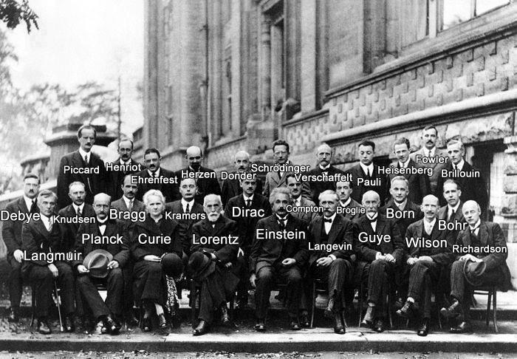
Figure 1. Figure caption…
References are listed in the order of appearance in the text. The source of references are listed in the following way: if you refer to one source, then mention on this way [1], if there are two then [2,3], and if there are more of them on this way [4-6].

CONCLUSION
Here comes the conclusion of a manuscript presented at the International Conference on Physical Aspects of Environment. The following information is important for authors: the manuscript is limited to 5 pages for regular contributed talks and posters and 8 pages for an invited talk. Please prepare your manuscript on this template and do not exceed the number of pages. If the manuscript is not prepared on the given template or exceeds the number of pages, it will be returned back to the authors for adjustments, which will result in a delay of the publishing process.

Acknowledgements
This work is partially supported by our Ministry under the grant NO 12345.

REFERENCES
- G. Eason, B. Noble, and I. N. Sneddon, 1955, On certain integrals of Lipschitz–Hankel type involving products of Bessel functions, Phil. Trans. Roy. Soc. London, vol. A247, pp 529–551
- Y. Yorozu, M. Hirano, K. Oka, and Y. Tagawa, 1987, Electron spectroscopy studies on magneto-optical media and plastic substrate interface, IEEE Transl. J. Magn. Japan, vol. 2, pp 740–741, [Digests 9th Annual Conf. Magnetics Japan, p. 301, 1982]
- McDonald D J, Dollinger R and Sarjeant W J, 1988, A method of characterizing high energy density capacitors for power conditioning systems, Proc. of the 18th IEEE Power Modulator Symp. pp 345–348
- Hanif M, Sneddon P H, Al–Ahmad F M and Reid N, 2009, The perceptions, views and opinions of university students about physics learning during undergraduate laboratory work, Eur. J. Phys. 30 85–96
- J. Clerk Maxwell, 1892, A Treatise on Electricity and Magnetism, 3rd ed., vol. 2. Oxford: Clarendon, pp 68–73
- M. Young, 1989, The Technical Writer’s Handbook. Mill Valley, CA: University Science

